User defined Function
1st way to write the function
function functionName(parameterList) {
function body;
}

Event : event provide the bridge between html and JS code. Event is a delegation model. once user interact with html tags like p, div, button, browser different type of event generate.
JS provided lot of pre defined event. All event start pre-fix on followed by event name.
onClick
onDblClick
onMouseOver
onMouseOut
onKeyUp
onkeyDown
onSubmit
onChange
onBlur
onFocus

BOM and DOM hierarchy
Browser Object Model
Document Object Model
JavaScript provided two pre-defined hierarchy ie BOM and DOM

Object - property
Behaviour
Object ---property
Behaviour
Object ---------property
Behaviour
Object

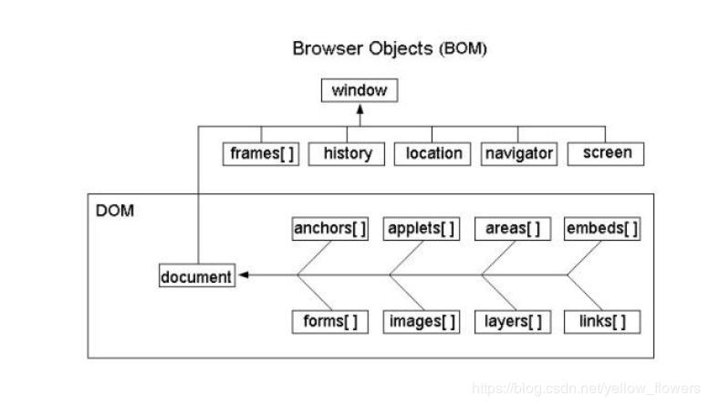

DOM : lot of programming language like JavaScript , Java, Python, php, .net they provided function or methods which help to read, write and update html content dynamically.
Using JavaScript if we want to read, write and update dom content (html contents dynamically). JS provide few pre defined function start the getElementXXX format.

